USEF/USDF # 343634, Level 4

Opening date: Aug. 1, 2023

ESDCTA Recognized - www.ESDCTA.org

Closing Date: received by Sept. 30, 2023

ESDCTA Garden State Classic & CBLM
41st Annual Colonel Bengt Ljungquist Memorial Dressage Championships

October 12, 13, 14 & 15, 2023
Horse Park of New Jersey, Allentown NJ
2024 Great American Insurance Group/USDF Regional Qualifier 2024 CBLM Qualifier

OFFICIAL PRIZE LIST

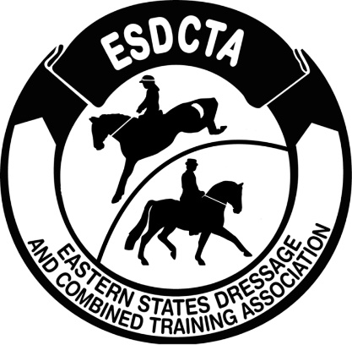
Competition Licensee: Judges:
ESDCTA/Holly Cornell, President Barbara Ebner (S-NJ)
Kem Barbosa (S-NJ)
Manager: Kathy Grisolia Cindi Wylie (S-FL)
(631) 338-6340 Amy McElroy (S-SC)
kgrisolia@aol.com Susan Buchanan (S-FL)
Lori Barnard (S-VT)
Assistant Manager: Lisa Toaldo Margaret Boyce (R-NJ)
(201) 874-0373
Dentist2.lt@gmail.com TD: Joyce Hardesty (R-MO)

Secretary: Veterinarian: Foundation Equine
Ellen Brindle-Clark (609) 291-0535
(609) 351-1054
13 Bunting Ave.
Burlington, NJ 08016 Farrier: George Sanchez
ellen@dressageexperiencesms.com Night Watch:
Braiding: TBA
Assistant Secretary:
Shannon Bossung Website: www.esdcta.org
(703) 431-5663 (text is best Online Entries: www.horseshowoffice.com
sgp588@hotmail.com Announcer: Gary Maholic & Mary Alice Goss

Photographer: Michelle Morganstern Photography
michellemorgensternphotography@gmail.com

Show office hours: Wed. 12:00 pm to 7:00 pm Thurs. 6:30 am – 6:00 pm,

Fri.- Sat. 6:30 am – 6:00 pm, Sun. 6:30 am – end

For CBLM Qualifying information go to
http://www.cblm.org/wp/wp-content/uploads/2023/02/23CBLMRules-1.pdf
Qualifying dates: September 12, 2022 to September 19, 2023

Email qualification form to: entries@scriptsrides.com

CLASS LIST
Thursday Class | Friday Class | Saturday Class | Sunday Class | Class Description | Divisions  * | Fee  $ | 2024 GAIG-  Q add | 2024 CBLM-  Q no fee
101 | 201 | 301 | 401 | USEF Training Level Test 1 | Open | 50
102 | 202 | 302 | 402 | USEF Training Level Test 2 | Open | 50 |  | CBLM
103 | 203 | 303 | 403 | USEF Training Level Test 3 | Open | 50 | $15
111 | 211 | 311 | 411 | USEF First Level Test 1 | Open | 50
112 | 212 | 312 | 412 | USEF First Level Test 2 | Open | 50 |  | CBLM
113 | 213 | 313 | 413 | USEF First Level Test 3 | Open | 50 | $15
121 | 221 | 321 | 421 | USEF Second Level Test 1 | Open | 50
122 | 222 | 322 | 422 | USEF Second Level Test 2 | Open | 50 |  | CBLM
123 | 223 | 323 | 423 | USEF Second Level Test 3 | Open | 50 | $15
131 | 231 | 331 | 431 | USEF Third Level Test 1 | Open | 55
132 | 232 | 332 | 432 | USEF Third Level Test 2 | Open | 55 |  | CBLM
133 | 233 | 333 | 433 | USEF Third Level Test 3 | Open | 55 | $15
141 | 241 | 341 | 441 | USEF Fourth Level Test 1 | Open | 55
142 | 242 | 342 | 442 | USEF Fourth Level Test 2 | Open | 55 |  | CBLM
143 | 243 | 343 | 443 | USEF Fourth Level Test 3 | Open | 55 | $15
150 | 250 | 350 | 450 | FEI Prix St. Georges | Open | 65 | $15 | CBLM
151 | 251 | 351 | 451 | FEI Intermediate I | Open | 65 | $15 | CBLM
156 | 256 | 356 | 456 | FEI TOC (PSG or I-1) | Open | 65 | $15 | CBLM
152 | 252 | 352 | 452 | FEI Intermediate II | Open | 65 | $15 | CBLM
153 | 253 | 353 | 453 | FEI TOC (I-2 or GP) | Open | 65 | $15 | CBLM
154 | 254 | 354 | 454 | FEI TOC (Int A or B, GPS) | Open
155 | 255 | 355 | 455 | FEI Grand Prix | Open | 65 | $15 | CBLM
158 | 258 | 358 | 458 | FEI Para TOC (Excludes Freestyle) | Open | 65
157 | 257 | 357 | 457 | FEI Pony TOC(Excludes Freestyle) | Open | 65
*Any Open class with 3 or more in any division will be pinned by division.

MUSICAL FREESTYLE CLASSES
Thurs. Class | Friday Class | Saturday Class | Sunday Class | Class Description | Divisions* | Fee  $ | 2023 GAIG-  Q add | 2023 CBLM-  Q no fee
161 | 261 | 361 | 461 | USEF Muscial Freestyle TOC  (Training through 4th Levels) | Open | 65 | $15 | CBLM
162 | 262 | 362 | 462 | FEI Musical Freestyle TOC | Open | 65 | $15 | CBLM
163 | 263 | 363 | 464 | USDF Pas de Deux TOC | Open | 35ea |  | CBLM
*Any Open class with 3 or more in any division will be pinned by division.
Materiale Classes
Thurs. Class | Friday Class | Saturday Class | Sunday Class | Class Description | Divisions | Fee  $ | 2023 GAIG-  Q add | 2023 CBLM-  Q no fee
174 | 274 | 374 | 474 | Materiale 3, 4 & 5 YO  Fillies/Mares | Open | 50
175 | 275 | 375 | 475 | Materiale 3, 4 & 5 YO Colts/Geldings/Stallions | Open | 50

EVERY CLASS OFFERED HEREIN IS COVERED BY THE RULES AND SPECIFICATIONS OF THE CURRENT USEF RULE BOOK AND WILL BE CONDUCTED AND JUDGED IN ACCORDANCE THEREWITH.

2023 CBLM Championship Classes (all are qualifiers for 2024 CBLM Championships)

Thurs  Class | Friday Class | Saturday Class | Sunday Class | Class Description | Divisions | Fee  $ | 2023 GAIG-  Q add
 |  | 302YSDB | - | Training Level (USEF T-2) | YR, Senior - Division B | 70
 | 222SDA | - | - | Second Level (USEF 2-2) | Senior Rider-Division A | 70
 | 222SRDB | - | - | Second Level (USEF 2-2) | Senior Rider-Division B | 70
 | 222JY | - | - | Second Level (USEF 2-2) | Junior/Young Rider | 70
152CO |  | - | - | Intermediate II (FEI I-II) | Open | 85 | $15
160CO |  | - | - | Training Level Musical Freestyle | Open | 85
163CO |  | - | - | Third Level Musical Freestyle | Open | 85 | $15
164CO |  | - | - | Fourth Level Musical Freestyle | Open | 85 | $15
162CO |  | - | - | Intermediate 1 Musical Freestyle | Open | 85 | $15
 | - | 302CJ | - | Training Level (USEF T-2) | Junior | 70
 | - | 312CA | - | First Level (USEF 1st-2) | YR,Senior-Division A | 70
 | - | 332CA | - | Third Level (USEF 3-2) | Senior Rider-Division A | 75
 | - | 332CB | - | Third Level (USEF 3-2) | Senior Rider-Division B | 75
 | - | 332CJY | - | Third Level (USEF 3-2) | Junior/Young Rider | 75
 | - | 350CA | - | FEI Prix St. Georges | Senior Rider-Division A | 85 | $15
 | - | 350CB | - | FEI Prix St. Georges | Senior Rider-Division B | 85 | $15
 | - | 361CO | - | First Level Musical Freestyle | Open | 85 | $15
 | - | 362CO | - | Second Level Musical Freestyle | Open | 85 | $15
 | - | 362.GPO | - | FEI Grand Prix Musical Freestyle | Open | 85 | $15
 | - |  | 475CA | USDF Pas de Deux | Open | 45 ea.
 | - | - | 402YSDA | Training Level (USEF T-2) | YR/Senior-Division A | 70
 | - | - | 412YSDB | First Level (USEF 1st-2) | YR/Senior-Division B | 70
 | - | - | 412CJ | First Level (USEF 1st-2) | Junior | 70
 | - | - | 442CA | Fourth Level (USEF 4th-2) | Senior Rider-Division A | 75
 | - | - | 442CB | Fourth Level (USEF 4th-2) | Senior Rider-Division B | 75
 | - | - | 442JY | Fourth Level (USEF 4th-2) | Junior, Young Rider | 75
 | 251CO | - |  | FEI Intermediate I | Open | 85 | $15
 | 255CO | - |  | FEI Grand Prix | Open | 85 | $15

EVERY CLASS OFFERED HEREIN IS COVERED BY THE RULES AND SPECIFICATIONS OF THE CURRENT USEF RULE BOOK AND WILL BE CONDUCTED AND JUDGED IN ACCORDANCE THEREWITH.

DEFINITIONS/ELIGIBILITY:
JR/YR – Riders are eligible to compete in these classes until the end of the calendar year in which they reach the age of 21. FEI JR Tests - only riders ages 14-18. FEI YR Tests - only riders ages 16-21. FEI Pony Tests - only riders ages 12-16. FEI Children Tests - only riders ages 12-14. Include birth date on entry.
AA – Adult Amateur – Individuals possessing current amateur certification are only eligible as AA from the beginning of the calendar year in which they turn 22. Only active USEF members may obtain amateur status.
PE – Para Equestrian – Riders must have a current USEF Dispensation Certificate which indicates their classification status to be eligible. All tests in standard arena.
CBLM – Colonel Bengt Ljungquist Memorial Championship qualifying class for 2024. Riders must be member of a participating GMO at the time of the show to be eligible.
USDF Q – Qualifying class for 2024 GAIG/USDF Regional Championships. Declare qualifying ride on entry form and pay additional $15 qualifying fee prior to start of class.

SHOW FEES: Individual Class fees shown in Class List
Great American/USDF qualifying (USDF-Q) add $ 15.00
USEF fee (D&M $15, USEF $8) $ 23.00 per competing horse.
USDF non-member fee (for each NM owner & rider) $ 35.00 Change Fee $ 20.00
USDF Affidavit Fee $ 5.00
Horse Stall (noon Thurs.-6 p.m. Sun) $300.00 for duration of show
Day Stall ( 6 am – 6 pm) $90.00/day
Bedding $ 10.00 per bag PRE-ORDERED
$ 11.00 per bag AT SHOW
Camper/RV Hookups (electric & water) $ 160.00/4 nights
Day parking fee for non-stabled horses $ 35.00/horse/day
Office fee $ 45.00 per entry, non-refundable
Incomplete Entry Fee (all docs not r’cvd by 9/30) $ 30.00
Late fee (If accepted, received after closing date) $ 50.00 per entry
Non-Compete (If accepted, plus stabling or day parking) $ 80.00 per horse Class Sponsorship $ 25.00 per class
Championship Class Sponsor $ 50.00 per class
Entries: Entries should be made online at www.horseshowoffice.com All stabling and other special requests are granted on a first come basis. Show management reserves the right to cut off entries prior to closing date if show is full. All paperwork must be completed and submitted online by September 30 at 5:00 pm.
Checks: Payments by check will be accepted at www.horseshowoffice.com until closing date.
Refunds: Before closing date, less office fee. After CD: USEF fee, Q fees, & any paid extra bedding refunded for notified scratches prior to show; no refunds for no-shows. All refunds will be less 5% processing fee. No other refunds after closing date, including classes canceled due to weather, terrorism, or Acts of God.
Bounced check policy: $50 fee; entry wait listed until payment settled.
PayPal/Credit Card dispute: $70 charge per dispute, chargeback and/or withdrawal.
Online Entries: No extra processing fees, see website for details. www.horseshowoffice.com

Rules Governing the Col. Bengt Ljungquist Memorial Championships Finals

The same tests used to qualify will be used in the Finals, except the FEI Children Pony, Junior & Young Rider tests.

The tests must be ridden from memory and without whips.

No horse/rider team may ride Hors de Concours in a Finals class.

Entries for the Finals classes may be made online (www.horseshowoffice.com) or mailed (received by 9/30/2023) to the current year’s Finals Entry Secretary, Ellen Brindle-Clark along with all payments and necessary documents.

A horse/rider team may qualify at more than one level and all qualified horse/rider teams are permitted to compete in the Finals in consecutive qualified levels; this includes the corresponding Freestyle finals.

Only ONE horse/rider combination may show in the Finals. If two riders qualify the same horse at different levels, the choice must be made and only one Finals horse/rider combination will be accepted by the Finals Show Secretary (exception: Pas de Deux).

During the Finals competition, no horse entered in a Ljungquist Final may be ridden by anyone other than the rider entered in the Final on that horse until that combination has finished their Finals class(es); this includes the awards ceremony. (At this point, the new horse/rider combination may compete in open classes with new entry form and bridle number.)

Training Level and First Level Finals for Senior/YR riders will consist of two divisions: a) riders who have not competed at or above Third Level at a USEF licensed show, and b) riders who have competed at or above Third Level at a USEF licensed show.

Second and Third Level Finals for senior (and/or YR) riders will consist of two divisions: a) riders who have not competed at or above the FEI Prix St. Georges level or in any of the FEI Young Rider levels at a USEF licensed show, and b) riders who have competed at or above the FEI Prix St. Georges level or in any of the FEI Young Rider levels at a USEF licensed show.

Fourth Level Finals for senior riders will consist of two divisions: a) riders who have not competed at or above the FEI Intermediate I at a USEF licensed show, and b) riders who have competed at or above the FEI Intermediate I at a USEF licensed show.

Prix St Georges Finals for senior riders will consist of two divisions: a) riders who have not competed at or above the FEI Intermediate II at a USEF licensed show, and b) riders who have competed at or above the FEI Intermediate II and/or B at a USEF licensed show.

A Division A rider may compete in Division B, but a Division B rider may NOT compete in Division A.

Regardless of the Division entered, only ONE Level per entrant (A or B, not both) may be ridden in at the Championships.

The Pas de Deux Finals class MUST be held on Sunday of the Finals Competition.

Finalists are NOT required to be stabled on grounds.

The Championship competition is to be held within USDF Region 1 only.

Awards Ceremony
Riders placing in Col. Bengt Ljungquist Memorial Championship classes must be present, mounted and in full riding attire for awards ceremonies (Ten places for Training & First (excluding MFS), ten places for all the rest of the Championship classes). Failure, without prior permission of the competition manager, in consultation with the Technical Delegate, the Awards Coordinator, to be present and properly attired will eliminate the official score and placing and the next highest score will move up in placing. In the case of inclement weather, unmounted ceremonies may be held.

Awards Ceremony Schedule:
A tentative schedule for the Awards Ceremonies will be printed in the “Show Program” and the official schedule will be posted in the show secretary’s office by noon on the day prior to the beginning of the competition & on www.horseshowoffice.com and www.esdcta.org

Garden State Classic Information

AWARDS:
- Open show: Trophy & ribbons to sixth place in all classes with 3 or more per division. Ribbon for classes with only 1.
- Championship classes: Special award to Champion, prize money to Champion ($200), Reserve ($100) and 3rd place ($50); ribbons to 10th for Training & First Levels (excludes freestyles), ribbons to 8th all other levels. Prize money will be mailed within 14 days of end of show. Awards ceremony schedule will be in the Program and will be posted on www.horseshowoffice.com
  - Separate finals classes are offered for Junior riders at Training, First and Second levels and Junior/Young Riders at Third and Fourth levels (excluding Freestyles). Young Riders must compete in the appropriate Senior division at Training, First and Second levels. If there are 3 or more Junior/ Young Riders at any of the FEI levels (excluding Freestyles), Junior/Young Riders will be pinned by division for the corresponding level(s).
- Garden State Classic Show High Score Awards for each level & division: Open, AA & Jr/YR for Training, First, Second, Third, Fourth, FEI, MFS
- Amy Parsons Memorial Award – Saturday Highest AA Score for 60 & over. Prize & $100 cash.
- Breed High Score Awards Including: TBA
USEF Rule DR129.9: Except for USEF/USDF Championship classes and for FEI Pony Riders, FEI Junior and FEI Young Rider Freestyles, in order to enter a freestyle class at any level, a horse/rider combination must have received a minimum score of 63% for Training through Fourth levels and 60% for FEI levels in the highest test of the declared freestyle level or any test of a higher level at a Federation /USDF Licensed Dressage Competition or FEI recognized Dressage Competition or “open” Dressage class (i.e. open to all breeds) at a Federation Licensed Competition held prior to the competition where the horse/rider combination is entered to ride a freestyle class. To enter an FEI Para Dressage Freestyle class, © USEF 2022 DR - 59 a horse/rider combination must have received a minimum score of 60% in any FEI Para Dressage test (Introductory, Novice, Team, Individual) at the rider’s classified Grade. This score may be earned at a USEF/USDF licensed Dressage Competition or FEI recognized Dressage Competition or “open” Dressage class (i.e. open to all breeds) at a Federation Licensed Competition held prior to the competition where the horse/rider combination is entered to ride a freestyle class. A photocopy of the test verifying eligibility, or copy of the USDF score verification, must be submitted with the entry for a freestyle class. All FEI Pony Rider Tests are equivalent to Second Level; all FEI Junior Tests are equivalent to Third Level; all FEI Young Rider Tests are equivalent to PSG; and the USEF Brentina Cup (Young Adult) Test and FEI Young Rider Grand Prix 16-25 Tests are equivalent to Intermediate II. For purposes of freestyle qualification, all are considered equivalent to the highest test of that level and may be used to enter a freestyle at that level or a level below. Young Horse and FEI Children Tests cannot be used for freestyle qualification at any level.

STABLING:
Permanent 10 X 10 stalls, 10’ overhang wood walls with chainlink tops. Bedding should be ordered in advance ($10.00). No initial bedding. Please order your extra bedding with entry. There will be a limited quantity of extra bedding available at the show and it will be $11.00 per bag.

Stabling is limited and are on a first come basis and tack stalls may be rescinded if horse stalls run out.
DO NOT put any items in empty stalls. Doing so will result in you being billed for a tack stall.
Golf carts available for rent, email manager for details.

TIMES:
- Ride Times will be emailed to competitors and posted on www.horseshowoffice.com and www.esdcta.org by October 7.
- Entry acknowledgement via email.
- Please include LEGIBLE email address and cell phone number on entry form.
- Riders assume responsibility for checking online entry and stabling status on/around closing date to verify correct information; management not responsible for errors, omissions.

ACCOMMODATIONS (Make your reservations early!):
Hampton Inn & Suites by Hilton Robbinsville, 153 West Manor Way, Robbinsville, NJ 08691. 609-258-0300 offers a special rate starting at $139.00 per night. Mention NJ Horse Park – CBLM before September 12th to get this rate.

DIRECTIONS:
Physical address is 626 Route 524, Allentown NJ 08501.

ARENAS:
Competition: Four or more 20 X 60 competition arenas on all-weather sand / clay footing. Warmup Footing also all-weather sand/clay.
HOSPITALITY: Complimentary Competitor dinner Saturday 6 pm in pavilion
Additional tickets can be purchased for $...
Food trucks will be onsite Thursday, Friday, Saturday and Sunday
VENDORS: Indoor/Outdoor vendor space available, contact Lisa Toaldo at dressage@esdcta.org or by phone 201-874-0373
CAMPING:
Full hookups (electric and water) on grounds, no dump station. Indicate rig length and breaker amp (20, 30, 50 amps available) on entry form.

Entry Information:
Entry Information Requirements: Competitors are responsible to provide valid membership numbers on the entry form for all horse, owner, rider, and trainer names listed on the entry form. USEF and USDF registration is verified electronically if valid membership numbers are provided on the entry form. Safe Sport Training must have been completed for USEF membership to be valid. You may be asked to provide copies of your membership documents if your memberships cannot be verified for any reason.
No horse will be permitted on the grounds without a valid health certificate or proof of vaccinations (Equine Influenza Virus & Equine Herpes Virus (Rhinopneumonitis) within 6 months prior to arriving. Rule GR845
SAFE SPORT TRAINING is required for all riders, owners and trainers and coaches within 30 days of membership. If Safe Sport Training has not been completed within 30 days of membership, entries will not be accepted until proof of completion is provided. If membership is renewed during show, Safe Sport Training must be completed within 30 days or results will be nullified. New for 2023: Parents of minors who are signing as trainer on USEF entries must have a current USEF Competing membership and must have completed safesport training.
Entries must be received by Midnight of the closing date. Any entry still requiring a signature, payment, or copies of proof of valid membership (including Safe Sport Training) by September 18th will be considered incomplete and will incur a late paperwork penalty fee of $30. No refunds after closing date, for any reason.
- All fees must be paid in US funds. Fees must be paid with entry. Entries not accompanied by fees will be considered late and not entered until fees are received including any late or post entry fees. Returned checks will nullify entry until debt is satisfied. Returned check fee is $50.
- Entries submitted after closing date will be considered late, see below.
- Numbers will not be given out until entries have been submitted to the show AND owners, riders and coaches or trainers have signed all entry blanks.
- Only one horse‐rider combination per entry form.
- Management reserves the right to cut off entries prior to closing date if show is full.
Late Entries: Late entries may be accepted after the closing date if space is available, upon payment of an additional late entry fee of $50. All late entries must enter and pay online – email for late entry permission.
Policy for Class Changes and Filling Scratches in classes: Must be eligible for class. Must have previously entered in competition as a competing or non‐competing horse.
Para-Equestrian competitors and their horses are no longer exempt from USDF memberships. Para- Equestrian competitors will now be required to have a USDF participating or group membership or a Non Member fee will apply. All horses will need a life or HID USDF membership.
Day Trailer parking: Pay per day parking fee and park in areas designated by show management.
Musical Freestyles: Music must be on good quality CD or submitted electronically with entry. Sound check will be on Friday evening or early Saturday morning, check with show office. Competitor is responsible for attending sound check to make sure music works properly and for picking up their music at the end of the show.
Numbers must be worn at all times when a horse is being walked, exercised or ridden. All competitors must check into the show office even if they have their number.
Show Management reserves the right to vary or add officials and refuse any entry for a cause; to disqualify any exhibitor and/or his or her horse for cause; to cause an exhibitor to forfeit his or her ribbons and winnings for cause; to return any entry and/or stall fee before or during the show for cause; all without being liable for damage or compensation. Show management reserves the right to make any changes deemed necessary for the safe and efficient conduct of this competition.
Weather/Acts of God/Accidents or Emergency Policy: Management reserves the right to cancel any classes due to hazardous weather, Acts of God, Accidents or Emergencies. Every effort will be made to reschedule with priority given to USEF Program classes. No refunds for cancellations due to hazardous weather, Acts of God, Accidents or Emergencies.
No Shows: All “No Shows” that have not contacted the show office will be considered a scratch for the rest of the show and time slots may be filled. Exhibitors enter with this understanding and agreement.
"Attention Competitors as of January 1, 2019, if you are a USEF competing member 18 years of age or older you are required to take the core Safe Sport training within 30 days of activating our membership. Take the Safe Sport Training at USEF.org by logging into your member dashboard."
Membership/Registration Requirements for GAIG/USDF Qualifying Classes: Riders must be current USDF Participating members & USEF members (Junior, Senior or Life) in good standing and this included Safe Sport Training. Horses must be USDF Lifetime Registered and USEF Annual or Lifetime Recorded. Horses with only an HID are not eligible. Owners must be current USDF Participating or Business members & USEF members (Junior, Senior or Life) in good standing. For current Great American/USDF Championship requirements, go to www.usdf.org/competitions/competitionschampionships/regionals/index.asp.
Great American/USDF Qualifying Classes: Please indicate that the class is to count for qualifying by placing a Q after the class number. Class fee plus additional $15 fee must be paid prior to start of the class. Qualifying will not require a separate ride. See USDF 2024 GAIG/USDF Regional Championship Program Rules pages for membership requirements.
Show Schedule and Ride Time Conflicts: It is the responsibility of the rider to inform the management of any time conflicts as soon as possible after receiving the schedule.

Additional Stabling Information:
- Stable Group: Please list stable group on entry form and use only one group name for each stable group to ensure that your group will be stabled together.
- Stalls will be ready to use by 11:00 am on Thursday
- Any stall changes MUST be cleared with show office.
- Trailer-ins must pay daily grounds fee and park in designated areas.
- No exhibitor may withdraw horses from a licensed show after it has commenced or remove them from the showgrounds without permission of the show secretary or show manager.
- Lungeing in designated areas only.
Pets: Dogs must be on leashes or otherwise restrained AT ALL TIMES while on show grounds, including in the stable area and NO pets are allowed inside coliseum. Dog owners are solely responsible for any damages, claims, losses or actions resulting from their dogs’ behaviors. Dogs should not be kenneled overnight in the stable area. Dog owners failing to comply will be issued a Yellow warning card and non-compliance may result in further USEF penalties.
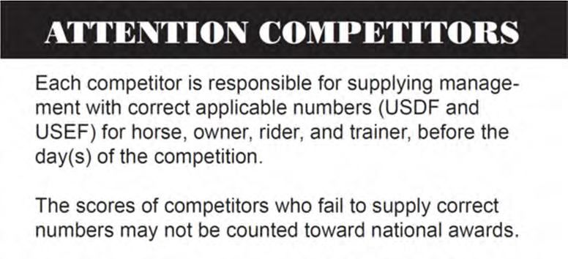
ATTENTION COMPETITORS –HEADGEAR RULE FOR DRESSAGE
Protective headgear –DR120.6 (GR801.6) From the time horses are officially admitted to the competition grounds by competition management, anyone mounted on a horse at any time on the competition grounds, including non-competing riders, riders on non-competing horses, mounted participants in exhibition classes and those competing in all classes and tests, including Para-Equestrian tests, must wear protective headgear as defined by this rule and otherwise in compliance with GR801. Any rider violating this rule at any time must immediately be prohibited from further riding until such head-gear is properly in place. Protective headgear is defined as a riding helmet which meets or exceeds ASTM (American Society for Testing and Materials)/SEI (Safety Equipment Institute) standards for equestrian use and carries the SEI tag. The harness must be secured and properly fitted. Unless jackets are waived, while in the competition ring, exhibitors wearing protective headgear must wear a short, dark jacket, dark tailcoat (only permitted for tests above Fourth Level), or Armed Services or police uniform (if eligible), dark hat covers (where applicable) and must other-wise conform to DR120 (see GR801).
MODIFIED DRESS CODE FOR RIDERS IN OPPORTUNITY CLASSES
Riders in classes and tests at all levels in Level 1 Competitions, and riders in Opportunity classes in Level 2 and Level 3 Competitions, may compete wearing breeches and shirts of any color as permitted in DR120.8. Jackets or vests of any type are allowed but not required and neckwear may be worn only if the rider chooses to compete in a riding jacket. Boots and protective headgear are required as specified in DR120.1-6. USEF DR120.5. ACCORDINGY, JACKETS ARE NOT REQUIRED FOR ANY RIDERS IN THE OPPORTUNITY CLASSES AT THIS COMPETITION.

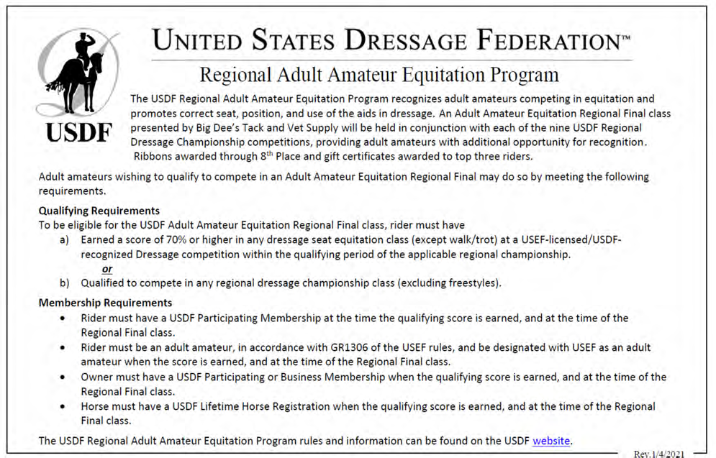
USEF MOTORIZED VEHICLE STATEMENT:
GR1301.7 & GR 1301.8 Minors who do not have a valid driver’s license which allows them to operate a motorized vehicle in the state in which they reside will not be permitted to operate a motorized vehicle of any kind, including, but not limited to, golf carts, motorcycles, scooters, or farm utility vehicles, on the competition grounds of licensed competitions. Minors who have a valid temporary license may operate the above described motorized vehicles as long as they are accompanied by an adult with a valid driver’s license. The parent/legal guardian or individual who signs the entry blank as a parent or guardian of a minor operating a motorized vehicle in violation of this rule are solely responsible for any damages, claims, losses or actions resulting from that operation. Violations of this rule will be cause for penalties against those responsible for the child committing the offense. Wheelchairs and other mobility assistance devices for individuals with disabilities are exempt from this rule. The unsafe use of personal electronic transport devices, as determined by the competition officials and management in their sole discretion, that do not require a driver’s license to operate, including but not limited to Segways, hover boards, and single wheeled scooters is prohibited on competition grounds. Operating such devices in areas where people gather may be deemed “unsafe use” if there is a risk of harm to others. If the operator of the device is a minor, the parent/legal guardian or individual who signs the entry blank as a parent or guardian of a minor operating the device in violation of this rule is accountable and may be subject to penalties. Wheelchairs and other mobility assistance devices for individuals with disabilities are exempt from this rule.

About Col. Bengt Ljungquist (USDF)
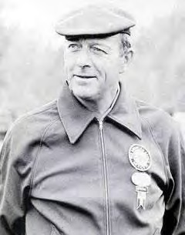
Colonel Bengt Ljungquist devoted a decade to furthering dressage in the United States. He developed a judges’ training program that continues today and conducted the first organized forums, which gathered together the day’s most learned trainers and aspiring judges. His dedication to and leadership in the pursuit of excellence in dressage in the U.S. was recognized by his induction into the USDF Hall of Fame in 1998.
Born into a Swedish military family in Sweden, Ljungquist continued the family tradition by joining the Swedish Army after he completed secondary school. In 1934 he received his cavalry commission, which he later resigned, along with many of his brethren officers, during the Finnish- Soviet Winter War to join the Finns and defend their country.
After the Finnish Soviet Winter War (1939-1940) he returned to Sweden and its army, where he studied and had a tour of duty as an instructor at the Military Academy at Karlberg. Ljungquist’s military career included being sent to Ethiopia as part of the Swedish Military Mission to help establish a cadet school and to train Imperial Guards. He was also commander of the Swedish cavalry cadet school. In 1955, he was promoted to commander of the Royal Horse Guards and stationed in Stockholm. As part of his military duties, Ljungquist organized the equestrian competition at the 1956 Stockholm Olympic Games.
An avid lifelong equestrian, Ljungquist began riding at the age of ten. An active national and international dressage competitor throughout his military career, he won the Swedish Dressage Championship six times. He was the team reserve rider for the 1960 Rome Games and represented his country at the 1964 Tokyo Olympics, aboard Karat. was even more famous in international circles as a fencer than as an equestrian. He was a reserve world fencing champion who competed on several Swedish Olympic fencing teams.
When the cavalry was mechanized, Ljungquist began a career as a civilian dressage trainer and instructor. During a visit with his sister at the 1968 Mexico City Olympics, he made a trip to the U.S. that sparked his interest in furthering dressage in the States. In 1969, he was invited to teach dressage at the Foxcroft School in Virginia. On that same trip, he gave a clinic at Lake Erie (OH) College Equestrian Center. That involvement led to other lessons and clinics, and 1978-9, he began training out of future “O” judge Linda Zang’s Idlewilde Farm in Davidsonville, MD also visiting Meredith Manor in West Virginia. Numerous notable dressage riders made the trip to Idlewilde to study with Ljungquist, who later became the U.S. dressage-team coach, a position he held from 1974 to 1978. In 1974, he brought the U.S. squad to the attention of the European dressage community when he coached World Championships competitors Elizabeth Lewis on Ludmilla, Edith Master on Dahlwitz, John Winnett on Leopardi, and Sidley Payne on Felix. Then in 1975, the U.S. team returned home from the Pan-American Games in Mexico with a team gold medal, as well as an individual silver for Hilda Gurney and Keen, an individual bronze for Dorothy Morkis and Monaco, and a fourth-place individual finish for John Winnett and Leopardi placed fourth. To cap off his international coaching accomplishments, Ljungquist guided the U.S. dressage squad to a team bronze medal at the 1976 Montreal Olympic Games.
An advocate for dressage-judge education, Ljungquist helped to develop a training program for the Potomac Valley Dressage Association. The PVDA program became the model for most judges’ training programs in the
U.S. In 1976 Ljungquist published his Practical Dressage Manual, which today remains a modern equestrian classic.
USEF MEMBERSHIP STATEMENT
Eventing Competitions at the Modified Level or above, Combined Driving Competitions at the Advanced Level, Dressage Competitions, Endurance Rides and Vaulting Competitions: (See GR828.4 of the Federation rules). Life, senior active and junior active members shall be eligible to participate in all classes at Regular Competitions, Eventing Competitions at the Modified Level or above and Combined Driving Competitions at the Advanced Level, Dressage, Reining and Vaulting Competitions and Endurance Rides. A non-member may participate as a handler, rider, driver, owner, lessee, or agent, at Regular Competitions, Eventing Competitions, Dressage Competitions, Reining Competitions and Combined Driving Competitions upon payment of a Show Pass fee. Participants in the following classes are exempted from the Requirements of this rule: 1) leadline; 2) exhibitions; 3) games and races; 4) classes for 4-H members; 5) walk trot (exception: Friesian performance FR231) and academy classes (academy classes are classes limited to horses used regularly in a lesson program); 6) USDF introductory level tests, pas de deux and quadrille classes; 7) NRHA Endorsed Reining Competitions. 8) Opportunity classes, 9) citizens of other nations who have proof, in English, of current membership in good standing of their own National Federation, 10) USEA beginner novice division; and 11) assistant handlers in Dressage Sport Horse Breeding classes

Fly hoods permitted for all classes (indoor and outdoor)
Fly hoods (ear covers) are permitted for all classes in order to protect horses from insects. The fly hood should be discreet in color and design and should not cover the horse’s eyes. After completion of the test, the rider or his/her representative is responsible for removing the fly hood to present to the designated ring steward for inspection to ensure that nothing prohibited has been added (for example, ear plugs). USEF DR121.7
